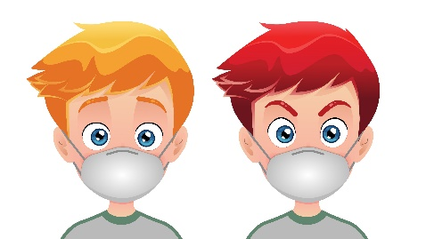
Summer Dancing
is Back!!!!

We will dance masked for starters and see how it goes.
Vaccination is required – 2 shots and a booster.
Tuesday evenings
7:15 – 9:15

Plus
May 10 & 24; June 7 & 21; July 5 & 19, Aug.2 & 16

Mainstream
May 17 & 31; June14 & 28; July 12 & 26; Aug. 9 & 23

J.A. Dulude Arena, Mel Baker Hall
941 Clyde Ave.(at Woodward; 1 km south of Carling)
Ottawa, ON

$10 per person (pay at the door)
Cash or credit card accepted.

For more information, contact
WendyGVanderMeulen@gmail.com or 613-282-0575 (call or text)

